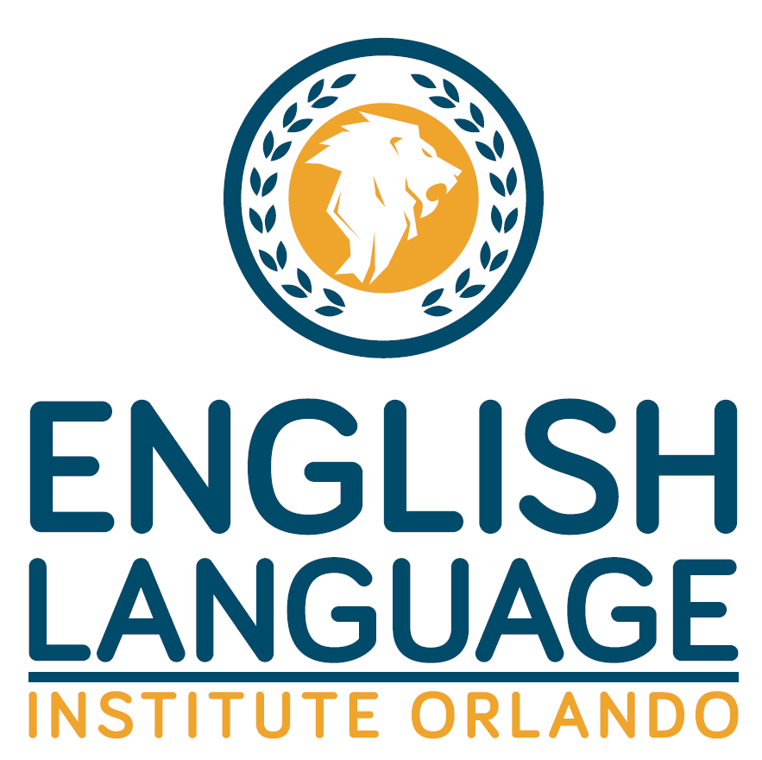
RELEASE OF LIABILITY, WAIVER OF CLAIMS, EXPRESS ASSUMPTION OF RISKS, AND HOLD HARMLESS AGREEMENT
In consideration of participating in the field trip to ___________________________ at ___________________________ on or about ___________________ (the “Field Trip”), hosted by the English Language Institute Orlando ____________________________________, I hereby agree as follows: I, _____________________________, for myself and, and English Language Institute Orlando teachers, Staff members, administrators, directors, employees, representatives, agents, and volunteers (collectively, the “Releasees”), from any and all liability and responsibility whatsoever, however caused, for any and all damages, claims, or causes of action that I, may have for any loss, illness, personal injury, death, or property damage arising out of, connected with, or in any manner pertaining to the Field Trip, whether caused by the negligence or otherwise. I fully understand that there are potential risks and hazards associated with the Field Trip and its related travel, including, but not limited to, possible injury or loss of life. I further understand that while on the Field Trip, I will be visiting locations and interacting with persons that are not associated with or under the control or supervision of the Releasees. Despite the potential risks and hazards associated with the Field Trip, I wish to proceed, and freely accept and assume all risks and hazards that may arise from my participation in the Field Trip and that could result in loss, illness, personal injury, death, or property damage, whether caused by the negligence of Releasees or otherwise. I further agree to comply with all applicable laws and ordinances and English Language Institute Orlando, rules and policies. I further hereby agree to indemnify and hold harmless the Releasees from any judgment, settlement, loss, liability, damage, or costs, including court costs and attorney fees for both the trial and appellate levels that Releasees may incur as a proximate result of any negligent or deliberate act or omission on my part during my participation in the Field Trip. In signing this agreement, I acknowledge and represent that I have read and understand it and that I sign it voluntarily and for full and adequate consideration, fully intending to be bound by the same.
I HAVE READ THIS AGREEMENT, UNDERSTAND THAT I AM GIVING UP SUBSTANTIAL RIGHTS BY SIGNING IT, AND VOLUNTARILY AGREE TO BE BOUND BY IT. Dated this ____________ day of _______________, 200___. __________________________________ Name of Participant __________________________________ ________________________________ Participant’s Signature Parent/Guardian’s Signature (I certify that I am 18 years of age or older) (If Participant is under 18 years of age)

