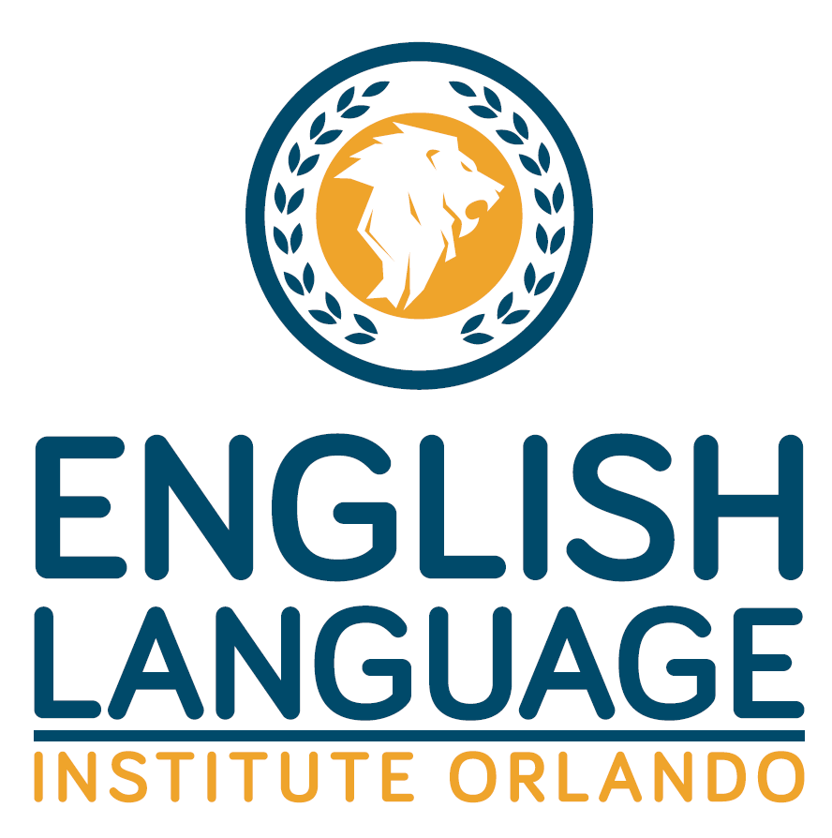

Financial and Health Statement

Emergency Medical Authorization Form

Field Trip/Photo/Video Permission Form

Information Release

I understand that my expenses (excluding personal miscellaneous expenses) per session while studying at English Language Institute - Orlando will be as indicated in the Prices and Dates addendum. I agree to accept full responsibility for these expenses. I have also read and understand the English Language Institute - Orlando cancellation and refund policy. I agree to accept full responsibility for my actions while participating in the Program and any related activities (including excursions and/or internships) and agree to assume all risk of harm arising from my participation, unless caused by English Language Institute Orlando’s negligence.
I hereby agree that English Language Institute Orlando shall have the right, in its sole discretion, to terminate my attendance in any English Language Institute Orlando program of study and to insist that I return to my country of origin within 24 hours of such termination by English Language Institute - Orlando. By his or her signature below, my parent or guardian agrees to insure that any minor under the age of 18 enrolled hereunder shall be returned to his or her country of origin within 24 hours of notification from English Language Institute Orlando that the student’s attendance in an English Language Institute Orlando program has been terminated.
In case of illness and/or injury, permission is granted to any appropriate medical center to examine or treat and make necessary referrals to outside physicians as indicated. Permission is also granted to release information regarding my health to other designated individuals. I authorize English Language Institute - Orlando to release information regarding my studies to my guardian or sponsoring agency. I further authorize English Language Institute Orlando to release my English Language Institute Orlando academic records to any colleges or universities to which I apply. I understand that I have the right to review my official English Language Institute Orlando student record.
I hereby grant English Language Institute - Orlando and its subsidiaries, associated companies and licensees, permission to photograph, record and videotape me while attending English Language Institute - Orlando or activities conducted by English Language Institute Orlando. I understand that English Language Institute Orlando will own the still photographs and/or video footage in which I appear, and have the unrestricted right to publish such photographs and use such video in any English Language Institute Orlando sales literature, on the English Language Institute Orlando Web site and in any other English Language Institute Orlando material, and shall have the right to license others to do the same. I further understand that this grant is intended to be worldwide in scope and to apply to all media now existing or hereafter developed.
I understand that English Language Institute Orlando shall not release my information, except as described above, to anyone or any organization or entity, outside of its subsidiaries and associated companies and licensees, without my written consent.

I confirm that I am the student named above, I am 18 years or older, and I have read the Financial and Health Statement/Information Release. *

Print:

Sign:

Date

